Inventory UI Recommendations

Inventory UI Screenshot
Below is the screenshot of the Inventory UI.
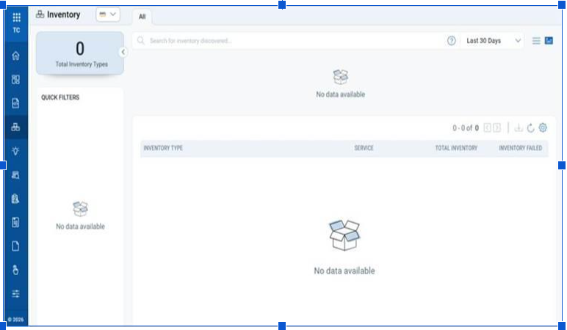

Observations
The current screen displays the message "No data available" in three different locations. This creates a poor user experience and does not provide meaningful guidance to users. The best practice, as I know, is that there should be a one-error concept. Below are the detailed observations:
- Generic "No data available" Messages
The same message is repeated multiple times without any context or actionable information.
Issues:
- The message does not explain why no data is available.
- Users are not informed about the next action they should take.
- Repeating the same text in multiple sections makes the interface feel unfinished and can frustrate users.
Each empty state should clearly explain what the section represents and guide the user toward the next appropriate action.
For all the warnings, errors, notifications, and other informative messages, the recommended format is “What is the issue?”, “Why the issue?”, and “How to fix the issue?”
2. Inconsistent Filter Placement
The screen currently contains:
- A Quick Filters panel in the left navigation.
- A separate Last 30 Days filter next to the search bar.
This creates an inconsistent filtering experience.
Recommendation:
- Consolidate all filters into a single location.
- Move the Last 30 Days filter into the left-side filter panel to provide a single, centralized filtering experience.
3. Filters Should Always Be Available
The Quick Filters panel should remain visible regardless of whether inventory data exists.
Instead of hiding filter options when there is no data:
- Keep the filters visible.
- Disable (gray out) filters that are currently not applicable.
- This maintains UI consistency and helps users understand the available filtering capabilities.
Possible filters could include (suggesting based on the screenshot):
- Inventory Type
- Service
- Total Inventory
- Failed Inventory
- Modified Date
- Created Date
- Status
- Any additional filters supported by the application
4. Search Results Section
The section directly beneath the search bar displays another "No data available" message.
This area appears unnecessary.
If the inventory list is already displayed on the page:
- The search field should simply filter that list.
- As the user types, matching inventories should appear automatically through incremental search or auto-suggestions, as per the same suggestion I had during the modernization of the document ecosystem.
- A separate empty search-results container adds unnecessary visual clutter.
5. No Help Link
There is currently no Help link available within the portal that allows users to directly access relevant documentation or support content. Even if more descriptive error messages and recommended next steps are provided, users may still wonder how to perform the suggested actions. Providing contextual Help links would enable users to quickly find the required guidance, reduce confusion, and improve the overall self-service experience.

Suggestions
Option 1 – Documentation Improvements (No UI Changes)
If documentation is the only area that can be updated, the empty-state messages should be rewritten to provide meaningful guidance.
Current Text | Suggested Text
No data available (Inventory) | No inventory discovered yet. Add an inventory to get started.
No data available (Search) | No inventory found matching your search.
No data available (Filters) | Filters will become available after an inventory is discovered.
These messages provide users with context and explain the expected next step.

Option 2 – Recommended UI Improvements
If UI changes are within scope, the following improvements are recommended.
Simplify the Layout
- Remove the empty search-results panel beneath the search box.
- Move the Last 30 Days filter into the left filter panel.
- Keep all filtering options grouped in one location.
Improve the Filter Experience
- Display filter categories at all times.
- Gray out filters that are not currently applicable instead of hiding them.
- This gives users a consistent interface regardless of the availability of data.

Improve the Empty State
Replace the inventory message:
No data available
with:
No inventory discovered yet.
Include a primary call-to-action button beneath the message:
Add Inventory
Selecting this button should navigate the user directly to the workflow to add a new inventory item.
Mandatory Suggestion – Help portal and Context Sensitive F1 Help

The problem
Today, users have to leave the product to find separate documentation to understand how to complete a task or what a specific field or button does. That breaks workflow, slows adoption of new features, and adds avoidable load on support.

Proposed solution
A two-quarter initiative delivering two connected capabilities:
- A centralized Help Portal — a single, searchable home for all user-facing documentation.
- Context-sensitive F1 help — pressing F1 (the standard in-app help key) on any page opens the specific help topic for that page: how to complete the task and what each field and button means. No searching, no leaving the workflow.

Approach
- Content is authored using a topic-based model, consistent with the tooling already used to maintain Qualys product documentation today — this extends existing capability rather than introducing a new platform to procure or learn.
- Every topic is tagged with a unique ID (UUID).
- Each UUID is mapped to its corresponding page in the product UI.
- When a user presses F1, the product looks up the current page's mapped UUID and opens the matching help topic automatically.

Roadmap
Phase | Timeline | Deliverable | Dependency
Phase 1 | Quarter 1 | Launch Help Portal; author and tag all content by topic, each assigned a UUID | Documentation team — independent, can start immediately
Phase 2 | Quarter 2 | Map UUIDs to in-product pages; enable F1 to launch the matching topic | Documentation + Engineering — mapping requires Dev support, scoped into Q2
This sequencing is deliberate: Phase 1 delivers standalone, visible value in Quarter 1 without waiting on engineering bandwidth. Phase 2 — the technical integration — is planned as a scoped cross-team dependency from day one, not a late-stage surprise.

Execution framework
Tracked on the product roadmap and run under Agile: one Epic for the overall initiative, broken into Stories per capability (portal content, UUID tagging, UUID-to-page mapping, F1 trigger), each broken into sprint-level Tasks. This gives leadership Epic-level visibility, Story-level milestones, and Task-level execution detail, all in one structure.

Why this matters
- Reduces support load from repetitive "how do I" and "what does this do" questions.
- Shortens time-to-competency for new and existing users.
- Reuses tooling and expertise already in place — low incremental cost to stand up.
- Establishes a topic-based content architecture that can extend to future products and portals, not just this one.

